## **Deep Learning**

**1. What is Deep Learning?**

* **Subset of Machine Learning:** Deep Learning (DL) is a specialized subfield of Machine Learning (ML), which itself is a subfield of Artificial Intelligence (AI).
* **Inspired by the Human Brain:** It uses artificial neural networks with multiple layers (hence "deep") to learn and make decisions, drawing inspiration from the structure and function of the human brain's interconnected neurons.
* **Learning Representations:** Instead of being explicitly programmed, deep learning models learn hierarchical representations of data. Lower layers learn simple features, and higher layers combine these to learn more complex concepts.
* 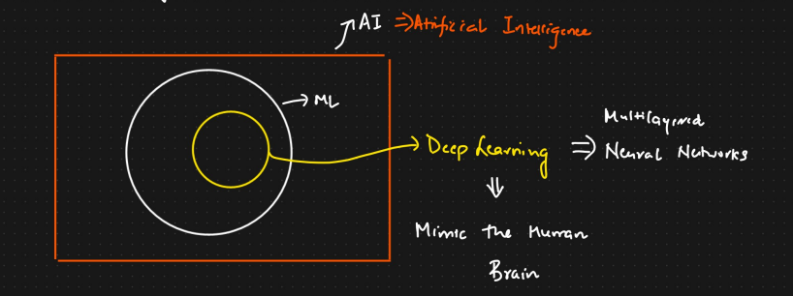

## **🏗️ Key Components**

### **1. Neurons and Layers**

* **Neuron**: Basic unit that receives inputs, applies a weight and bias, passes through an activation function.
* **Layers**:
  + **Input Layer**: Receives raw features
  + **Hidden Layers**: Process and transform inputs
  + **Output Layer**: Produces final predictions

### **2. Activation Functions**

Introduce non-linearity. Common ones:

* ReLU (Rectified Linear Unit)
* Sigmoid
* Tanh
* Softmax (for classification)

### **3. Loss Function**

Measures the error between predicted and true values.

* Examples: MSE (regression), Cross-Entropy (classification)

### **4. Optimization**

Backpropagation + Gradient Descent to adjust weights

* Optimizers: SGD, Adam, RMSprop

## **🛠️ Popular Architectures**

| **Type** | **Description** | **Example Use** |
| --- | --- | --- |
| **Feedforward NN (FNN)** | Basic dense layers | Tabular data |
| **Convolutional NN (CNN)** | Spatial hierarchies | Image classification |
| **Recurrent NN (RNN)** | Sequence modeling | Language modeling |
| **Transformers** | Attention-based, parallel | NLP, Vision |
| **Autoencoders** | Encoding/decoding for compression | Anomaly detection |
| **GANs** | Generator vs Discriminator | Image synthesis |

## **📚 Frameworks & Tools**

| **Framework** | **Language** | **Strength** |
| --- | --- | --- |
| **TensorFlow** | Python | Industry-grade, scalable |
| **PyTorch** | Python | Research-friendly, dynamic |
| **Keras** | Python | High-level, easy prototyping |
| **ONNX** | Interop | Model deployment/interchange |

## **📈 Use Cases**

* **Computer Vision**: Image classification, detection, segmentation
* **NLP**: Sentiment analysis, translation, chatbots
* **Speech**: Recognition, synthesis
* **Recommendation Systems**
* **Medical Diagnosis**, **Finance**, **Autonomous Vehicles**

**Core Architectural Paradigms (High-Level):**

* **Artificial Neural Networks (ANNs):**
  + **Concept:** The foundational building blocks. Consist of interconnected nodes (neurons) organized in layers (input, hidden, output). Each connection has a weight that is learned during training.
  + **What we study:** Neuron models (e.g., perceptron), activation functions (Sigmoid, ReLU, Tanh), feedforward propagation, backpropagation (for learning weights), loss functions, and optimization algorithms (e.g., Gradient Descent and its variants).
  + **Relevance:** Basis for all other deep learning architectures. Used for simpler classification and regression tasks on structured data.
* **Convolutional Neural Networks (CNNs or ConvNets):**
  + **Concept:** Specialized for processing grid-like data, such as images. Employ operations like convolution (to detect local features like edges, textures) and pooling (to downsample and create invariance).
  + **What we study:** Convolutional layers, filters/kernels, pooling layers (max, average), padding, stride, receptive fields, and well-known architectures (e.g., LeNet, AlexNet, VGG, ResNet, Inception).
  + **Relevance:** Dominant in computer vision tasks (image classification, object detection, segmentation), but also applied to other domains like NLP.
* **Recurrent Neural Networks (RNNs):**
  + **Concept:** Designed to handle sequential data (e.g., text, time series, speech) by having connections that form directed cycles, allowing information from previous steps to persist (memory).
  + **What we study:** Handling sequences, vanishing/exploding gradients problem, Long Short-Term Memory (LSTM) units, Gated Recurrent Units (GRU), sequence-to-sequence models, attention mechanisms (often studied alongside RNNs/Transformers).
  + **Relevance:** Crucial for Natural Language Processing (machine translation, sentiment analysis), speech recognition, time series forecasting.
* **Transformers:**
  + **Concept:** A more recent architecture (emerged prominently around 2017) that has revolutionized NLP and is increasingly used in other domains like vision. Relies heavily on "self-attention" mechanisms to weigh the importance of different parts of the input sequence, allowing for parallel processing of sequences (unlike traditional RNNs).
  + **What we study:** Self-attention, multi-head attention, positional encodings, encoder-decoder structures (e.g., BERT, GPT).
  + **Relevance:** State-of-the-art for many NLP tasks and showing great promise in computer vision (Vision Transformers - ViT) and other areas.

**5. Key Enabling Concepts & Tools:**

* **Transfer Learning:** Reusing a pre-trained model (trained on a large benchmark dataset like ImageNet or a massive text corpus) as a starting point for a new, related task. This is highly effective when you have limited data for your specific problem.
* **Embeddings:** Dense vector representations of discrete inputs (like words or categories) learned by the network, capturing semantic relationships.
* **Regularization Techniques:** Methods (e.g., L1/L2 regularization, Dropout, Batch Normalization) to prevent overfitting, where the model performs well on training data but poorly on unseen data.
* **Optimization Algorithms:** Advanced optimizers beyond basic SGD, such as Adam, RMSprop, AdaGrad, which help in efficiently navigating the complex loss landscapes of deep networks.
* **Hyperparameter Tuning:** The process of finding the optimal set of hyperparameters (e.g., learning rate, number of layers, number of neurons per layer) for a model, often requiring systematic experimentation.

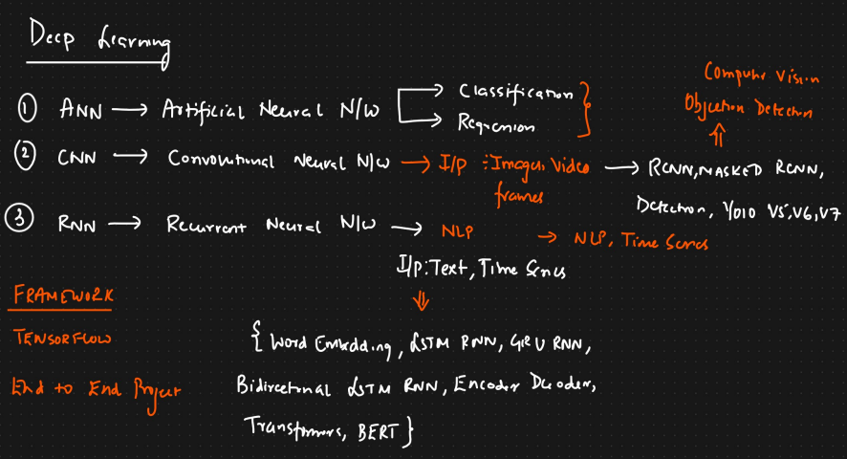

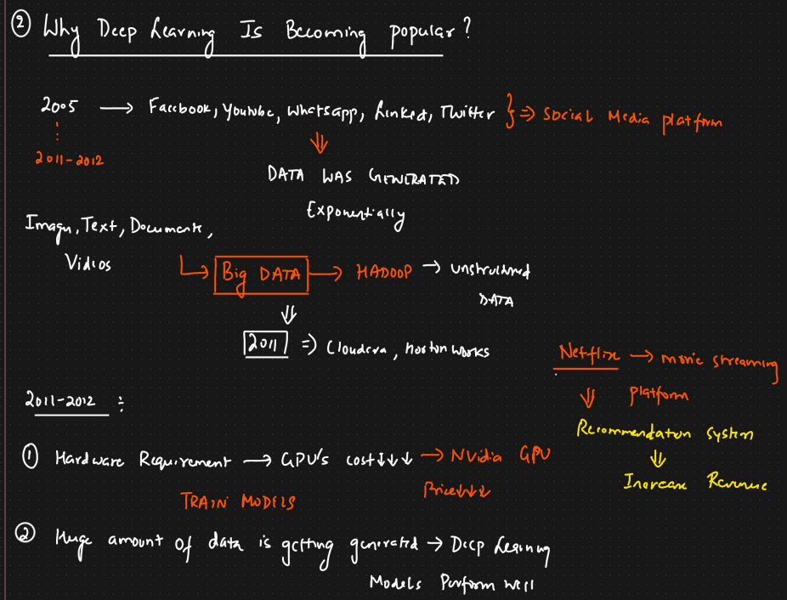

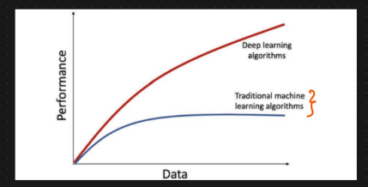

## **The Perceptron**

**1. Introduction & History:**

* The **Perceptron** is the simplest form of a neural network, a foundational algorithm for **supervised learning** of **binary classifiers**.
* It's a type of **linear classifier**, meaning it learns a linear decision boundary to separate two classes.
* It's inspired by a single biological neuron, aiming to mimic basic information processing.

**2. Analogy to a Biological Neuron:**

* **Inputs:** Like dendrites receiving signals.
* **Weights:** Represent the strength or importance of each input signal (synaptic strength).
* **Summation:** The cell body (soma) integrates the incoming signals.
* **Activation Function (Threshold):** If the integrated signal exceeds a certain threshold, the neuron "fires" (sends an output signal down its axon).

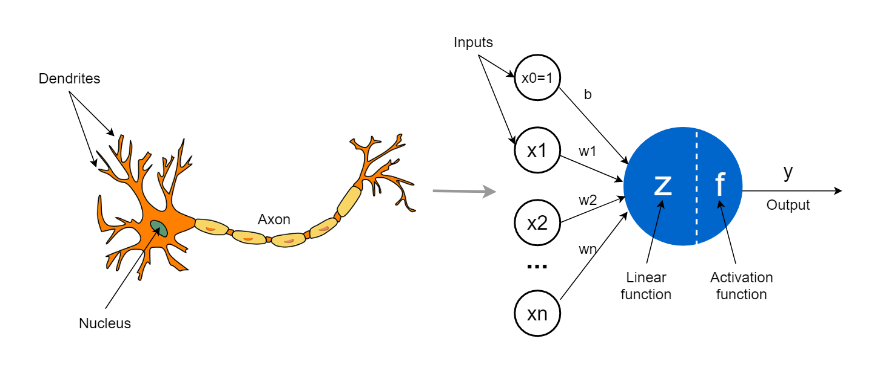

**3. Components of a Perceptron:**

* **Inputs (x1​,x2​,...,xn​):** A vector of numerical features representing an instance.
* **Weights (w1​,w2​,...,wn​):** A vector of real-valued numbers, one for each input feature. These are learned during training.
* **Bias (b):** A special weight that is not associated with any input feature (or can be thought of as a weight for an input that is always +1). It allows shifting the decision boundary away from the origin, increasing model flexibility.
* **Summation Function (Net Input):** Calculates the weighted sum of the inputs plus the bias.
  + Mathematically: 
* **Activation Function (Step Function):** Determines the output of the Perceptron based on the net input. The classical Perceptron uses a **Heaviside step function**:
  + Output is 1 if z≥θ (threshold).
  + Output is 0 (or sometimes -1) if z<θ.
  + Often, the threshold θ is incorporated into the bias term, so the activation function becomes:
    - Output is 1 if z≥0.
    - Output is 0 (or -1) if z<0.

**How a Perceptron Works (Forward Pass):**

1. **Receive Inputs:** The Perceptron takes an input vector x.
2. **Compute Weighted Sum:** Each input xi​ is multiplied by its corresponding weight wi​. These products are summed up, and the bias b is added: z=w1​x1​+w2​x2​+...+wn​xn​+b
3. **Apply Activation Function:** The result z is passed through a step activation function to produce the final output ypred​ (typically 0 or 1 for binary classification).
   * ypred​=1 if z≥0
   * ypred​=0 (or -1) if z<0
4. This output ypred​ is the Perceptron's prediction for the given input.

**5. The Perceptron Learning Algorithm:**

The goal of the learning algorithm is to find the optimal weights (w) and bias (b) that correctly classify the training examples.

1. **Initialization:**
   * Initialize weights (w) and bias (b) to small random values or zeros.
   * Define a **learning rate (η)**: A small positive value (e.g., 0.01, 0.1) that controls the step size of weight updates.
2. **Iterate through Training Data (Epochs):** For each training example (x(j),d(j)) where x(j) is the input vector and d(j) is the desired (true) output label (e.g., 0 or 1):
   * **a. Calculate Predicted Output:**
     + Compute the net input: z(j)=w⋅x(j)+b
     + Apply the step function to get the predicted output y(j).
   * **b. Calculate Error:**
     + The error is the difference between the desired output and the predicted output: error(j)=d(j)−y(j)
   * **c. Update Weights and Bias:** If error(j)=0 (i.e., the prediction is wrong):
     + 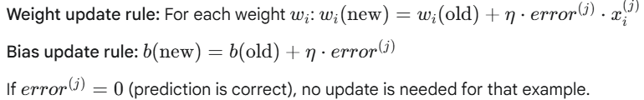
3. **Repeat:** Repeat step 2 for a fixed number of epochs (passes through the entire training dataset) or until all training examples are correctly classified, or some other stopping criterion is met.

**Intuition behind the update rule:**

* 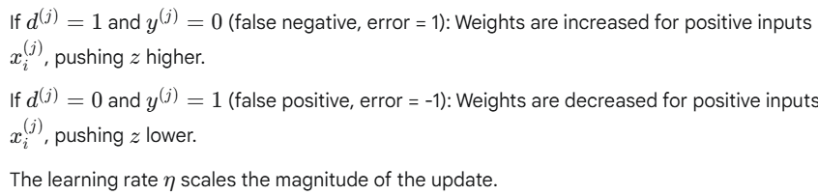

**Convergence:** The Perceptron learning algorithm is guaranteed to converge and find a solution (a separating hyperplane) **if and only if** the training data is **linearly separable**. If the data is not linearly separable, the algorithm will typically not converge and may oscillate.

**6. Mathematics Summary:**

* **Input Vector:** x=[x1​,x2​,...,xn​]
* **Weight Vector:** w=[w1​,w2​,...,wn​]
* **Bias:** b
* **Net Input (Weighted Sum):** 
* **Activation (Output y for binary classification, labels 0 and 1)**
* **Error (for desired output d and predicted output y):** e=d−y
* **Weight Update:** wi​←wi​+η⋅e⋅xi​
* **Bias Update:** b←b+η⋅e

Geometrically, the equation w⋅x+b=0 defines a hyperplane that separates the input space into two regions.

**7. Limitations of the Perceptron:**

* **Linear Separability:** The most significant limitation is that a single Perceptron can only classify data that is **linearly separable**. It cannot solve non-linearly separable problems, famously illustrated by the **XOR problem**.
* **Binary Output:** The classical Perceptron with a step function produces only binary outputs (0 or 1, or -1 or 1). It doesn't provide probability scores.
* **Sensitivity to Learning Rate:** If the learning rate is too high, the algorithm might overshoot the optimal weights and oscillate. If too low, convergence can be very slow.
* **Noisy Data:** Performance can degrade with noisy data or outliers.
* **Convergence on Non-Separable Data:** If the data is not linearly separable, the Perceptron learning rule will not converge; the weights will continue to change.

**8. Significance & Legacy:**

* **Foundation of Neural Networks:** Despite its limitations, the Perceptron was a crucial first step and forms the basic building block (neuron) for more complex, multi-layer neural networks (Multi-Layer Perceptrons or MLPs).

